Polyvinyl Chloride (PVC) flexible pipes are products that need to be revolutionized for our world that is more aware of the effects of plasticizers and phthalates on the environment. Redesigning flexible piping to be made of materials that do not have phthalate concentrations as high as PVC or do not leach plasticizers into the environment could greatly improve the effectiveness and sustainability of the product.
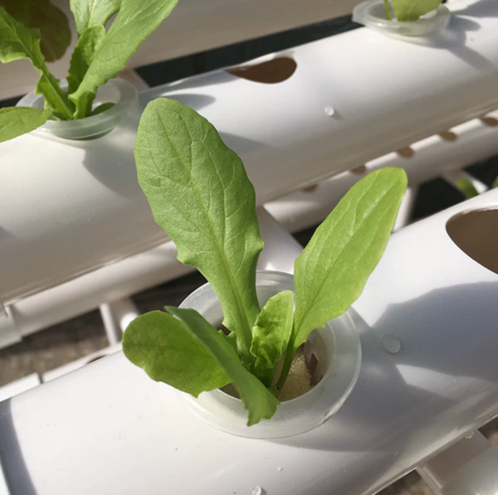
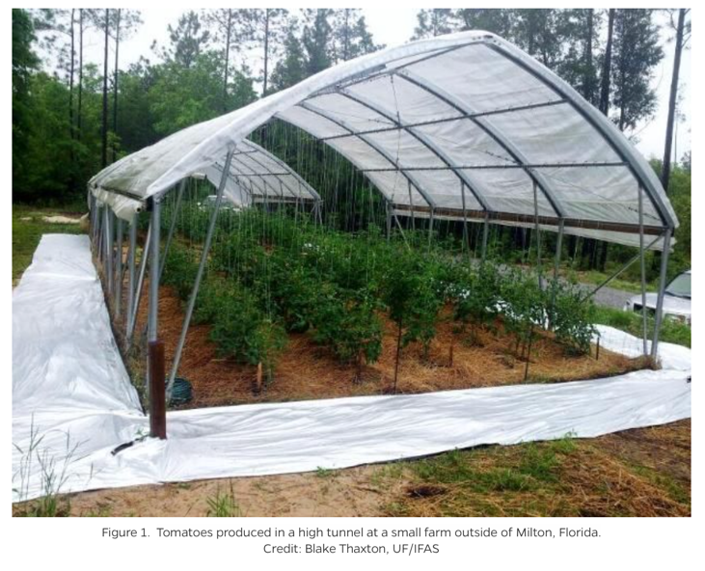
Figure 1: Hydroponics used in home gardening and horticulture with PVC piping.
Figure 2: Tomatoes grown by UF IFAS lab using PVC piping as drip irrigation.
PVC pipes are used for many important applications, one of which being irrigation and water transportation in greenhouses and gardens. Irrigation piping is vital to the efficiency and success of agricultural crops and plants; however, the high composition of plasticizers (phthalates), up to 45%, leaching into water and soil can dramatically affect crops and the people consuming them. Some flexible PVC materials are given high REACH Candidate List indicator values (0.25-0.51), showing that they are harmful to the environment. The goal for the design project would be to find a material that can replace flexible PVC piping in agriculture with lower plasticizer composition and environmental impact (carbon footprint or embodied energy).
One major advancement in irrigation has been the advent of hydroponics and aquaponics. A hydroponic system consists of growing plants or crops in water rather than soil, which has improved the sustainability of agriculture by conserving water and increasing yield. Having a system that increases overall benefits and is decreasing waste in water and runoff, however, is endangered by the leaching of plasticizers into the water by the hydroponic pipe product themselves. Improving this product would allow hydroponic and aquaponic systems to be effectively sustainable.
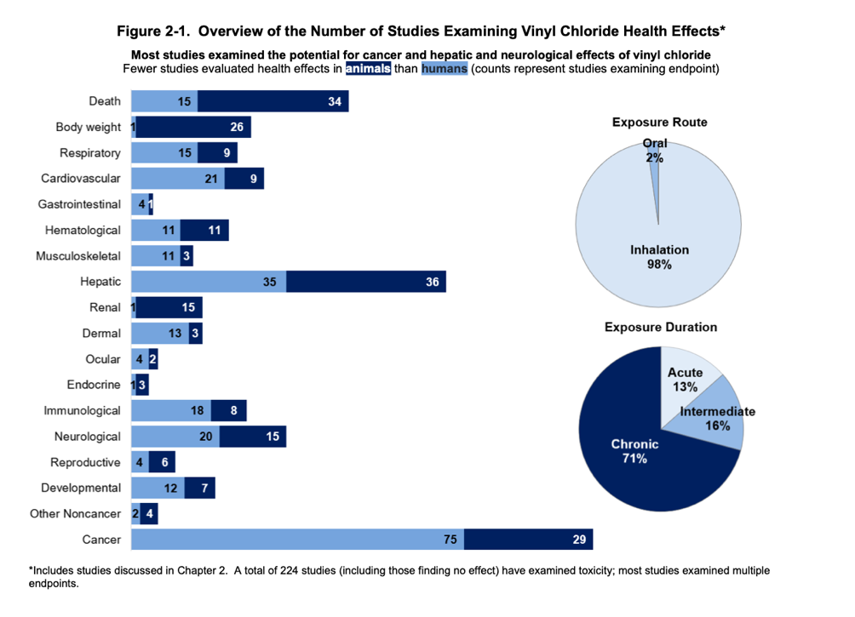
The Center for Disease Control (CDC) and the Agency for Toxic Substances and Disease Registry (ATSDR) have released toxicological profiles on many potentially harmful chemicals and substances, one of them being Vinyl Chloride, the primary component in polyvinyl chloride. Out of the long list of dangerous health effects, there is an emphasis on hepatic (liver), immune, neurological, developmental, and cancer effects. Figure 3 has been included in their profile for a general view of the dangerous health effects of vinyl chloride (and indirectly PVC) on humans and animals.
Figure 3: Infographic of different health effects of vinyl chloride to animals (dark blue bars) and humans (light blue bars).
The health effects become especially important as PVC flexible piping is also used for biomedical applications, so leaching of vinyl chloride into the human body directly could be extremely dangerous for patients. An article on the topic, “Plasticizer leaching from flexible PVC in low temperature caustic solution” (Shen et. al) directly states that “Flexible PVC is widely used in medical applications, such as catheters and bottles … However, direct contact with human flesh induces the leaching of plasticizer from the material.” While for this design project the main focus will be on the horticultural and agricultural benefits of redesigning flexible PVC piping, the biomedical applications and effects on humans cannot be ignored and could function as an area of future research or complexity in this project.
As mentioned briefly above, the main objective of the evolutionary design is to reduce the selective leaching of PVC flexible pipes and to improve the overall sustainability of the product. For the product to perform optimally, the new piping would have to function similarly to the old PVC pipes without the high composition of plasticizers/phthalates. Being able to transfer water, withstand a similar hydrostatic pressure, and have similar moduli or flexibility are key performance metrics for the redesign. A challenge is presented as plasticizers are used in these polymers applications to increase flexibility, so the new product must compromise the needs of matching PVC performance without the inclusion of plasticizers. Focusing mainly on an agricultural or horticultural application to the piping, the new product must not leach under UV (Ultraviolet) radiation, water in the environment, or with the presence of organic solvents.
Additionally, to improve the overall sustainability of the product, minimizing energy usage in production and processing through embodied energy and carbon footprint would be essential. Improving the recycling process and success would also be an important performance metric for the redesigned piping as “contamination by PVC in the recycling of waste plastic material produces a lot of problems” (Shen).
There are two areas of properties that can maximize the performance of the revolutionized product: practical and sustainable. The first entails the properties that will maximize the performance of the product as a flexible pipe that is similar to the existing PVC one. Using the GRANTA software to establish a framework for the new pipe, the properties of other potential materials can be compared to PVC. For a flexible pipe, the performance is optimized when the bulk modulus and durability against organic solvents are maximized, while the flexural modulus, elastic modulus, density, and water absorption are minimized. Bulk modulus, water absorption, and durability are all properties that correspond to the success of the material being made into a pipe and withstanding hydrostatic pressure. The other properties like flexural and elastic modulus correspond to the ability of the pipe to easily undergo bending stress and thus be flexible. Some other properties that would maximize performance would be high resistance to UV degradation, especially as a polymer, and ability to have food contact. Having a high resistance to UV degradation is especially important in the agricultural application of irrigation, as there is a high likelihood that the pipes used will be outside without much protection from UV radiation.
Moreover, there are properties that will optimize the performance of the product in terms of sustainability and energy efficiency such as reducing cost, plasticizer (phthalate) percent composition, carbon footprint, and embodied energy. While plasticizers are used to change the mechanical properties of materials, the goal of this design project is to see if the properties needed can still be obtained without adding phthalates. Also, while selective leaching and corrosion are alternative ways to study this issue, there is less available and quantifiable information provided for selective leaching in different materials; therefore, to avoid this entirely the project will remove plasticizers in the screening process altogether. These properties are important in the advanced screening and ranking process of design, as they are not design limiting properties (aside from phthalate composition.
The first ranked material property that needs to be considered is the bulk modulus, which is the resistance to hydrostatic pressure and volumetric strain. Having a bulk modulus that is equal to or greater than that of PVC is important for a material to be functional as a pipe, otherwise it would deform or fail under hydrostatic pressure. A material can be flexible and have no plasticizers, but without a sufficient bulk modulus it cannot function as a pipe and substitute for PVC, making it a design limiting property. Having a high bulk modulus is important to the agricultural applications for PVC in hydroponics, as the product must transport water and hold up under high water pressure inside the pipe. Second is the elastic and flexural moduli, which for PVC are equivalent values. The elastic modulus is the stiffness of a material undergoing basic tension or compression, and the flexural modulus is the ability of a material to undergo bending stress without deforming. Both mechanical properties are important for the pipe material to be considered “flexible” and be used in the same applications as PVC flexible piping. Similar to bulk modulus, if the flexural modulus is not comparable to the baseline values from the polyvinyl chloride, then it will not function in the applications needed – it is another design limiting property. While some PVC piping in horticulture is just used to hold plants in water, some pipes are bent into garden hoops and stretched across greenhouses, so a low elastic or flexural modulus is needed to properly succeed in these applications. Water absorption is another property that would allow the new material to function properly as a pipe, especially as water is the main substance transported by the product. If the material has a high water absorption rate after 24 hours (GRANTA), then it will not have any long-term success as a pipe or an irrigation channel for agriculture. As shown in Figure 2, the PVC piping can be used to irrigate crops or plants from above ground in a trellis or garden hoop system; therefore, having a less dense material is preferable and important to consider for this application. Overall, having a material with a similar or lighter density to polyvinyl chloride makes the product more accessible, efficient, and possibly cheaper. Finally, durability to organic solvents is a property that will allow the new material piping to be less resistant to leaching in different environments. This material property is very connected to the composition of a polymer and the inclusion of phthalates as some organic solvents actually are plasticizers; therefore, they will be susceptible to degradation due to solubility in a similar polar substance. Having a new property that has a high resistance to organic solvents (rated acceptable to excellent by GRANTA) could indicate that the material has no plasticizer or phthalate composition, or that it is resistant to leaching plasticizers into the surrounding environment. Both of those outcomes would be favorable to the project and the success of a substitute material for PVC piping.
For the screening phase, PVC (flexible, Shore A65) was chosen in GRANTA as the baseline for the polyvinyl chloride pipe, as it is the average between the other flexible PVC types available. This kind of flexible PVC has a plasticizer percentage of up to 40% and an elastic/flexural modulus of 8.7x10⁻⁴ – 0.00102, 10⁶ psi. In GRANTA, the first stage created was a screening stage for some constraints using the idealized material properties from above. The maximum plasticizer percentage was 40%, and the minimum bulk modulus was set to that of PVC Shore 65 – 0.218x10⁶ psi. Additionally, all the materials were screened having an acceptable or higher food contact ability and durability to organic solvents. To not restrict the pool of possible materials, all materials in the database were screened and afterwards only 1586 of 4249 passed. From the ranked material properties list from above, two to screen and rank are density and elastic/flexural modulus – Figure 4.

Density (lb./in^3) vs. Flexural Modulus (10^6 psi)
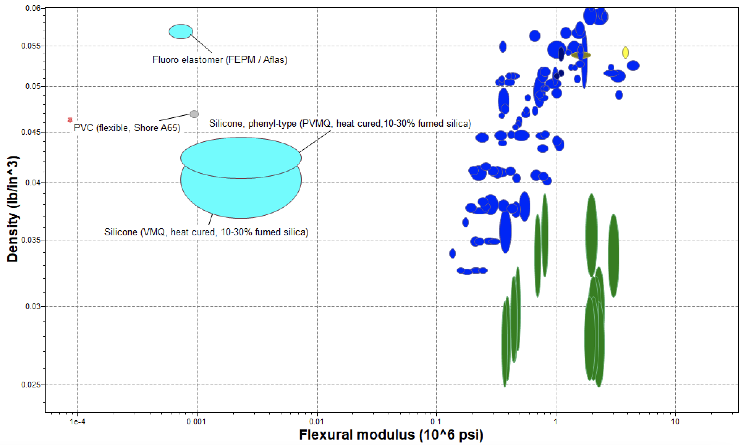
Figure 4: GRANTA chart of density versus flexural modulus where the baseline of Shore 65 PVC is shown in the grey bubble.
From this chart it can be interpreted that the materials closest in properties and performance to PVC Shore65 are Vinyl Methyl Silicone (Silicone VMQ) and Phenyl Vinyl Methyl Silicone (Silicone PVMQ). The other materials in the chart are natural materials and composites like wood (green) and other polymers (dark blue). While some have the required density, the flexural moduli of the other materials in the chart are orders of magnitude higher than the baseline.
Water Absorption at 24 hours (%) vs. Flexural Modulus (10^6 psi)

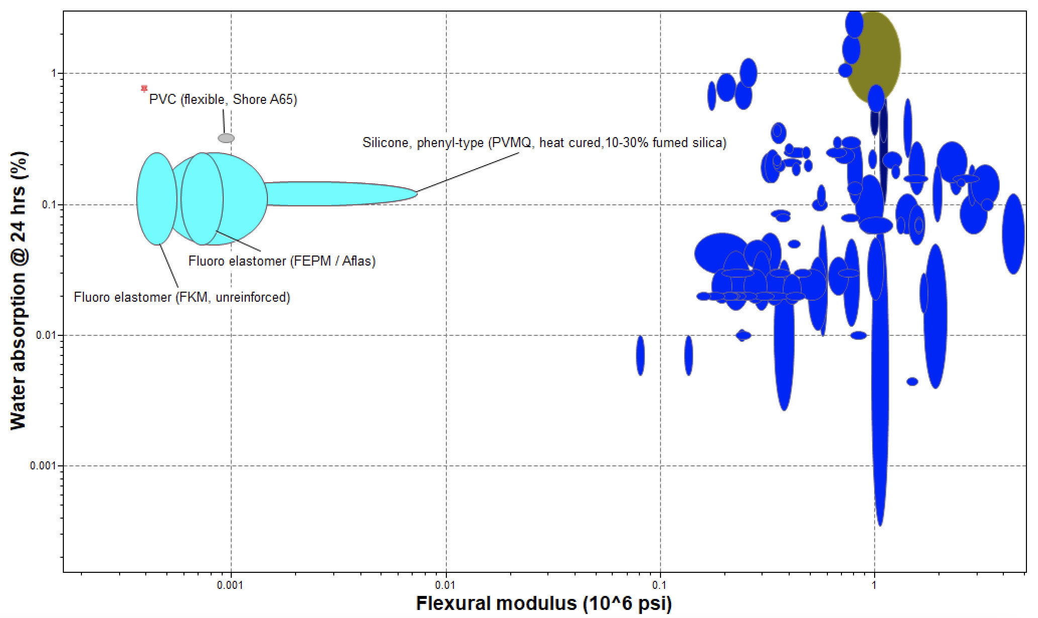
Figure 5: GRANTA chart of water absorption at 24 hours versus flexural modulus where the baseline of Shore 65 PVC is shown in the grey bubble.
Figure 5 depicts the other ranked property of water absorption against flexural modulus. Again, the Silicone PVMQ matches similarly to the baseline and has better resistance to water absorption than PVC. Fluoro elastomers (FEPM and FKM) appear to be similar to PVC and also more resistant to water absorption; however, these materials are slightly denser than PVC as seen in the previous graph.
Ranking of the different materials comes down to the sustainable properties of the materials, and some ways to demonstrate that are through carbon footprint and embodied energy of typical primary production of materials, and these charts are shown below.
Embodied Energy, primary production (BTU/lb.) vs. Flexural Modulus (10^6 psi)
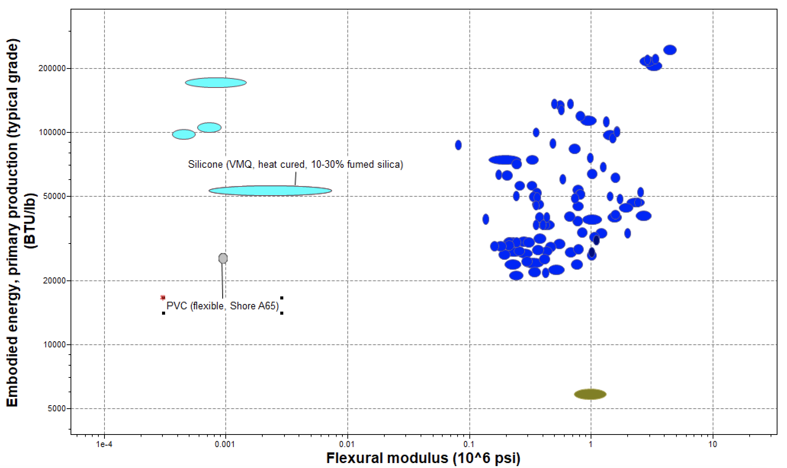
Figure 6: GRANTA chart of embodied energy during production versus flexural modulus where the baseline of Shore 65 PVC is shown in the grey bubble.

CO2 Footprint, primary production (lb./lb.) vs. Flexural Modulus (10^6 psi)
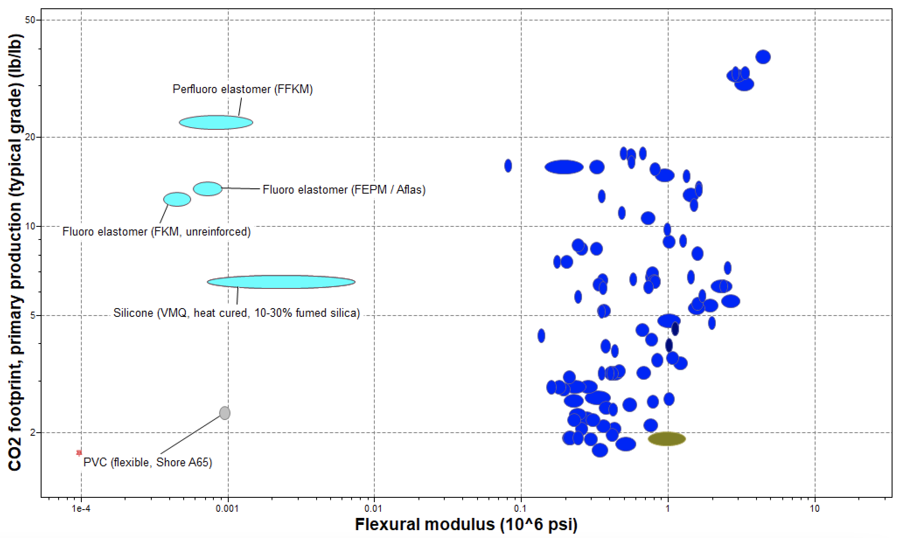
Figure 7: GRANTA chart of CO2 footprint from the primary production versus flexural modulus where the baseline of Shore 65 PVC is shown in the grey bubble.

In both cases, the carbon footprint and embodied energy of Silicone is about two times that of the baseline PVC; however, it is still the closest compared to the fluoro elastomers.
From the screening and ranking design processes and comparing the flexural modulus to density, water absorption, and carbon footprint the best material to replace flexible PVC piping would be Silicone (VMQ or PVMQ). As shown by the graphs, the functional properties of bulk modulus, flexural modulus, water absorption, density, and durability against organic solvents are all comparable or better than the PVC baseline even without the composition of plasticizers. Silicone is also suitable against UV radiation and has a very low EU REACH score of 0.01 compared to PVC 0.47, indicating that it is a much safer material to have and work with. The downside to Silicone is that it appears less sustainable when looking at carbon footprint, embodied energy, and recyclability. Silicone cannot be recycled and as indicated above, has higher embodied energy and carbon footprint compared to PVC. The material choice of replacing PVC with silicone is still viable as sustainability must consider both disposal and energy consumption as well as damage to the environment through leaching. In this application, because leaching is much more significant and harmful, the substitution of silicone will be an improvement to the overall sustainability and decrease in effect to the environment.
Aside from the challenge of implementing a material with greater energy consumption and less recyclability, there are also more practical impediments to having Silicone piping for agriculture and horticulture compared to PVC. Shore65 PVC has a maximum price of 1.17 USD/lb., while Silicone VMQ has a minimum of 2.33 USD/lb., so the increase price of material by about a dollar per pound could not be accessible or practical for agricultural investors. Moreover, PVC can be extruded, injected, and thermoformed very easily and well, whereas silicone cannot be thermoformed at all. A decrease in the available processing abilities also could prevent the practical implementation of silicone piping for hydroponics or agriculture.
The outcome of this design project illustrates why plasticizers are used in polymers and many applications despite the ecological and health problems they can cause. Plasticizers and phthalates allow for a cheap and potentially recyclable way for materials to become more flexible, which is significant for piping systems. The best material substitute for the existing PVC that preserves or improves on mechanical function and corrosion/leaching resistance is Silicone. While this will create a piping system that does not leach phthalates into the ground water or crops, it cannot be easily recycled and consumes a lot of energy in production.
Another way of thinking about this problem is to choose a baseline PVC that is less flexible and instead semi-rigid, which is also widely used in hydroponic systems shown below. The below application of semi-rigid PVC is used and desired by IFAS at UF for tomato cultivation.
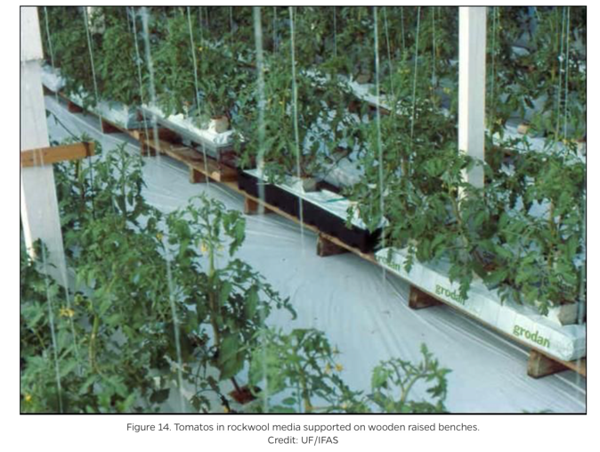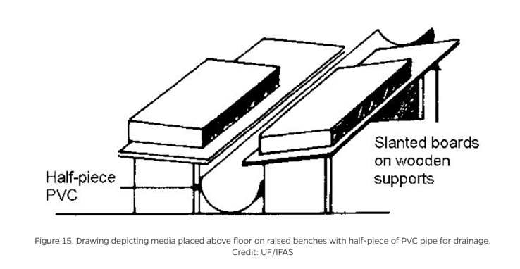
Figure 8 and 9: Depicting the uses of semi-rigid PVC by UF IFAS Lab in agricultural irrigation and hydroponics.
Allowing for this change, there are more materials that can be chosen for the application. Now that the flexural modulus issue has been ameliorated, ultra-high molecular weight polyethylene (PE-UHMW) and polypropylene (PP) copolymer (40% calcium carbonate) present as very feasible options for replacing PVC piping, with PP being the best choice as it is more energy conscious, cheaper, much safer (EU REACH), and can be easily recycled. The figures for these updated GRANTA charts can be found in the appendix.
This design project helps emphasize why plasticizers and phthalates are such a materials science and engineering problem moving forward in our more eco-conscious world. There must be a balance drawn between price, accessibility, and easy manipulation of mechanical properties with the possibility of endangering people or ecosystems with plasticizer leaching. While Silicone piping could be a potential solution to the problem of PVC piping, the lack of recyclability and increased energy consumption provide areas for further research into hydroponic applications of more rigid piping, or even bio-based plasticizers that are less harmful to the environment.

Appendix
Density (lb./in^3) vs. Flexural Modulus (10^6 psi)

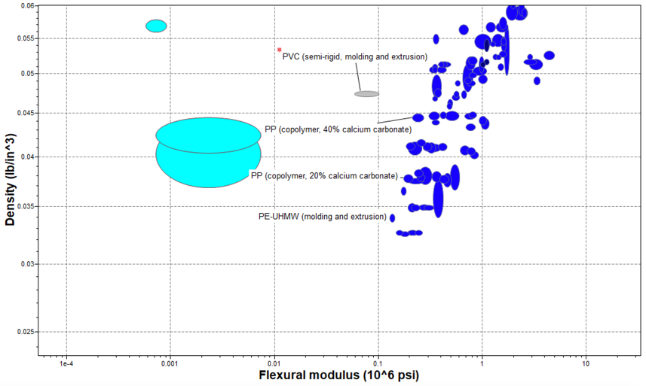
Figure 10: GRANTA chart of density versus flexural modulus where the baseline of semi-rigid PVC is shown in the grey bubble.
CO2 Footprint, primary production (lb./lb.) vs. Flexural Modulus (10^6 psi)
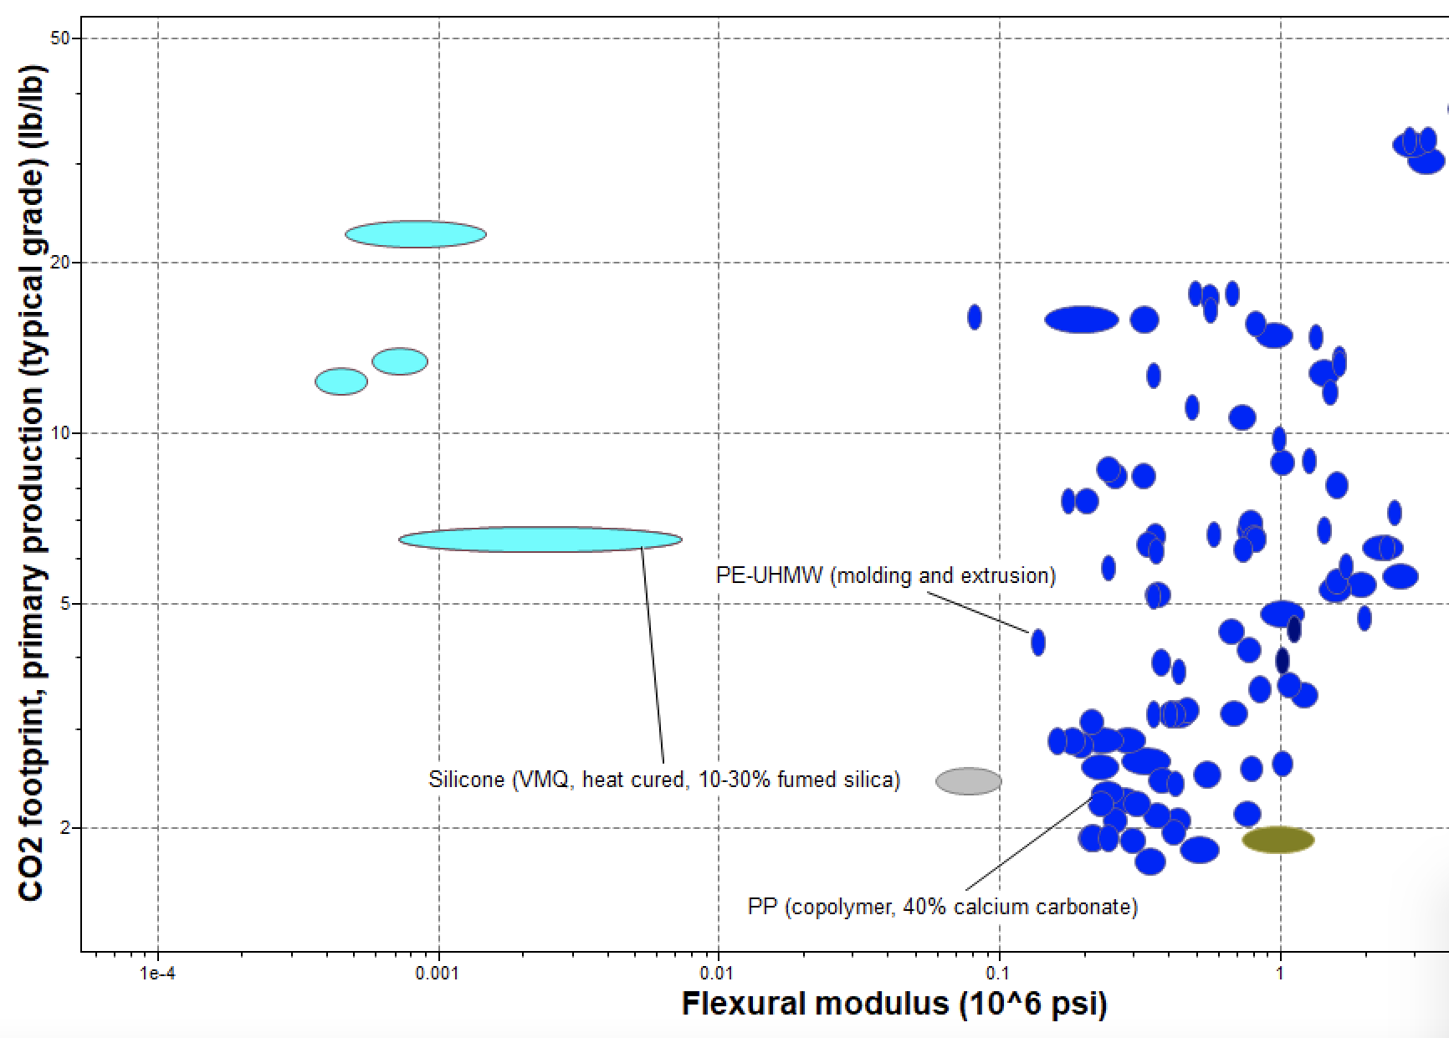
Figure 11: GRANTA chart of CO2 footprint versus flexural modulus where the baseline of semi-rigid PVC is shown in the grey bubble.

Embodied Energy, primary production (BTU/lb.) vs. Flexural Modulus (10^6 psi)

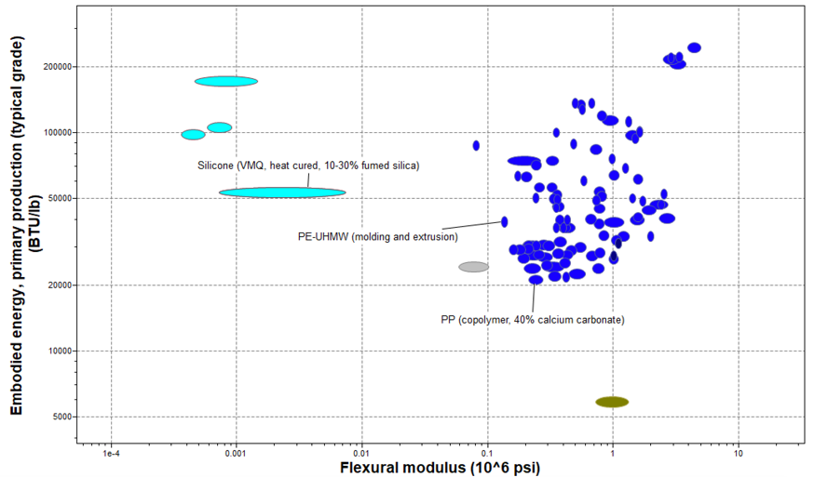
Figure 12: GRANTA chart of embodied energy versus flexural modulus where the baseline of semi-rigid PVC is shown in the grey bubble.

References

Ansys GRANTA EduPack software, ANSYS, Inc., Cambridge, UK, YEAR (www.ansys.com/materials)
Hochmuth, George, and Robert Hochmuth. “BULLETIN 327/CV195: Design Suggestions and Greenhouse Management for Vegetable Production in Solid Media in Florida.” Ask IFAS - Powered by EDIS, 11 Aug. 2022, edis.ifas.ufl.edu/publication/cv195. Accessed 24 Apr. 2024.
“Is PVC Safe for Aquaponics? - Go Green Aquaponics.” Gogreenaquaponics.com, gogreenaquaponics.com/blogs/news/is-pvc-safe-for-aquaponics.
Figure 1.
Reh, Christopher. TOXICOLOGICAL PROFILE for VINYL CHLORIDE. 2006.
Figure 3.
Shin, Shun Myung, et al. “Plasticizer Leaching from Flexible PVC in Low Temperature Caustic Solution.” Polymer Degradation and Stability, vol. 78, no. 3, Jan. 2002, pp. 511–517, https://doi.org/10.1016/s0141-3910(02)00198-2. Accessed 21 Apr. 2020.
Thaxton, Blake R., and Robert C. Hochmuth. “HS1273/HS1273: Tomato Cultivar Selection Considerations for Open-Field and Protected Culture in North Florida.” Edis.ifas.ufl.edu, 4 Oct. 2018, edis.ifas.ufl.edu/publication/HS1273.
Figure 2.

